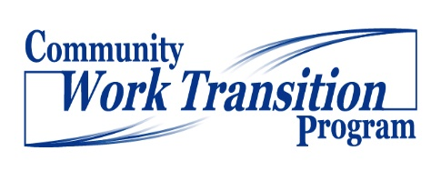Positive Personal Profile (PPP) Form

Student Name :

Brief Directions Here: Interview student in reference to …..

Dreams & Goals: | Interests:
Talents, Skills, and Knowledge (Include Work Related Skills): | Values:
Positive Personality Traits: | Environmental Preferences: Add dropdown box
Dislikes: | Life and Work Experiences:
Support System: | Accommodations:
(adapted with permission from TransCen, Inc.)

