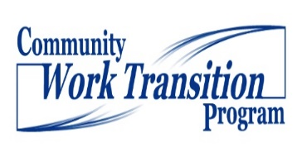

FAMILY INTERVIEW/CONVERSATION
(Adapted with permission from source material created by TransCen, Inc.)
Date:
Parent Name:
Student’s Name:
School District:
* Remember to take notes, either directly onto the Positive Personal Profile or to include into existing assessment information.
Section 1: Hopes, Dreams, Expectations, and Challenges
Please describe what a good life will look like for your son or daughter once they leave high school.

What dreams does your son or daughter have for themselves when they get older?

What is your son or daughter's greatest skill or attribute?

What does your son or daughter look like on their roughest day?

When thinking about your son or daughter's future, what worries you the most?

Section 2: School and Adult Supports
Do you fully understand what the school is doing to help prepare your son or daughter for adult life?
What style of communication works best for you (phone, written, text, or face-to-face)?

Do you feel like a respected and involved partner on your son or daughter's IEP team?

Have you been connected to any service agencies that might provide supports to your son or daughter when they are an adult?

Is your son or daughter currently receiving SSI or SSDI? If so, what questions or concerns do you have about those benefits as they relate to employment?

Section 3: Focusing on Employment
What are your expectations for your son or daughter's employment?

What would make you feel more comfortable about your son or daughter's employment future?

What activities does your son or daughter do at home that builds responsibility?

In what community do you see your son or daughter living as an adult?

Based on what you know about your son or daughter’s skills and interests, what types of jobs do you think they would enjoy?

In the community you live in now, are there any local businesses that you think your son or daughter would enjoy or be successful working at?

Do you know any business owners in your community that you could contact for a potential work experience for your son or daughter?

