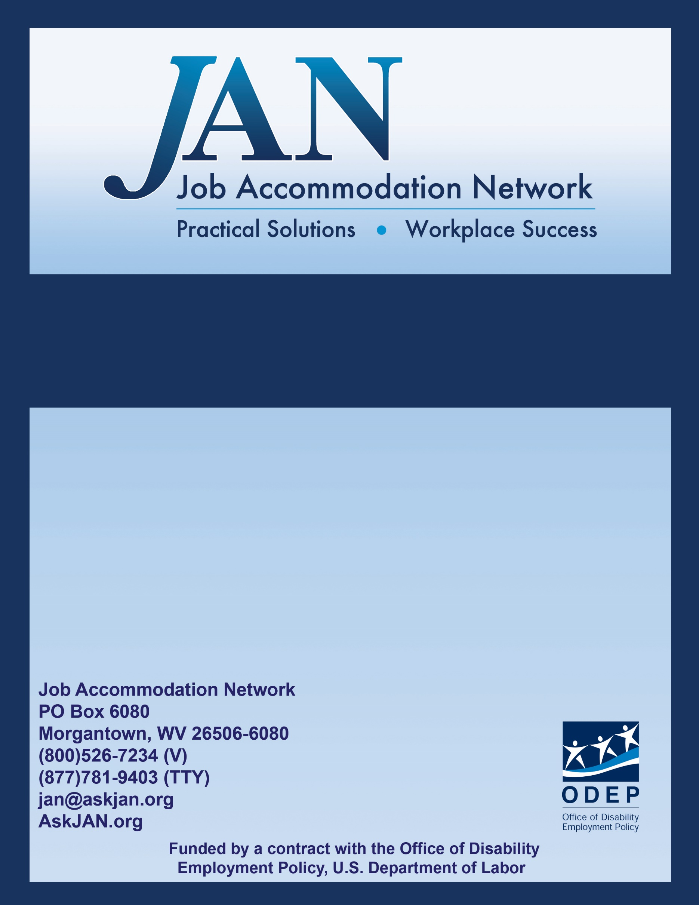
Effective Accommodation Practices (EAP) Series

Disability Disclosure
and Employment

JAN’S EAP SERIES

Disability Disclosure and Employment

Introduction
Deciding if, when, and how to share disability-related information with a prospective or current employer can be overwhelming. The decision-making process requires answering a number of personal questions that may be different with each employment experience. There is no single right or wrong approach to disclosing a disability. The disability disclosure decision-making process can include questions like: “Do I have an obligation to disclose?” “When is the right time?” “How much information does the employer need?” and “How will disclosing the information affect my employment?”
While JAN Consultants cannot decide what is the best approach to disability disclosure for everyone, the remainder of this document is a summary of issues and answers to some of the most frequently asked questions related to disability disclosure and the Americans with Disabilities Act (ADA). This information is relevant to both individuals with disabilities and employers.
Information about Disability Disclosure and Employment
Disability disclosure can occur during any stage of the employment process, including pre-employment, post-offer, and while employed – whether it be within days, months, or years of initially being hired. Generally it is up to the individual with the disability to determine the right time to disclose, given his or her particular circumstances. The ADA places restrictions on disability-related questions that can be asked of applicants and current employees so there are only limited situations when disclosure may be required. Applicants should be aware that covered employers are not permitted to ask non-voluntary disability-related questions on a job application. Disability-related questions can be asked after a conditional job offer has been made, but only if the same questions are asked of all applicants entering into the same job category. After an individual has started working, an employer may only ask disability-related questions if they are job-related and consistent with business necessity – for example, when an accommodation is requested or when an employee is having performance issues that may be related to a known medical impairment.
- Disclosure and Pre-Employment
With limited exceptions, an employer may not require an applicant to disclose information about a disability or medical impairment prior to making an offer of employment. However, there are situations when an applicant may need to disclose information about a disability during this early stage in the employment process. For example, if an accommodation is needed to complete an on-line application, participate in a job interview, or take an employment test, an applicant may need to disclose his or her disability to receive an accommodation.
Only applicants with disabilities are entitled to receive an accommodation under the ADA. When an accommodation is requested for the hiring process, and the need for the accommodation is not obvious, an employer may ask an applicant for reasonable documentation about his or her disability because the employer, in this instance, is entitled to know that the applicant has a disability in order to receive accommodation (EEOC, 1995). An applicant may be asked to provide a note from an appropriate professional (i.e., healthcare provider, rehabilitation counselor, etc.) that explains the individual’s disability, limitations, and need for accommodation. Applicants seeking further information regarding their rights under the ADA, should see the Equal Employment Opportunity Commission (EEOC) publication, Job Applicants and the ADA at http://www.eeoc.gov/facts/jobapplicant.html.
In limited circumstances, employers can ask applicants to voluntarily disclose their disability status without violating the ADA's restrictions on medical inquiries. Employers who are required to undertake affirmative action based on federal, state, or local laws, and those who use disability-related information to benefit individuals with disabilities may invite applicants and employees to voluntarily self-identify as having a disability. In requesting this information, an employer must state clearly, in writing or otherwise, that the information is being requested on a voluntary basis, that it will be kept confidential, that refusal to self-identify will not subject the person to any adverse treatment, and that the information will be used only in accordance with the ADA and federal laws that require affirmative action (e.g., Section 503 of the Rehabilitation Act). The voluntarily-disclosed information must be kept separate from the application. For more information, see JAN’s Consultants’ Corner, Affirmative Action and Disability: What Can Employers Ask? at https://AskJAN.org/publications/consultants-corner/vol05iss05.cfm.
- Disclosure and Post-Offer
Individuals are often compelled to share disability-related information during the post-offer stage of employment because many employers ask medical questions or require medical examinations before a newly hired employee begins working. Employers are not limited in the categories of questions that can be asked during the post-offer stage. This means that after receiving a conditional job offer, an individual may be asked about his or her medical history in its entirety, as long as the employer asks the same questions of other applicants offered the same type of job. An employer may ask specific individuals for more medical information if the follow-up questions are related to the medical information obtained during the post-offer inquiry or examination. While this essentially requires an individual to disclose information about disability – even when an accommodation is not needed – the information revealed during post-offer cannot be used to rescind a job offer unless it can be shown that the individual would be unable to perform the essential functions of the job (with or without accommodation), or would pose a direct threat to him/herself or others (EEOC, 1995).
- Disclosure to Receive Reasonable Accommodation
Generally there is no obligation to disclose disability-related information to an employer until the need for reasonable accommodation becomes apparent. Reasonable accommodation may be needed to participate in the hiring process, to perform essential job functions, or to receive a benefit or privilege of employment. The need to disclose and request accommodation will become evident when an individual knows there is a workplace barrier due to a disability. An accommodation can be requested even when a disability was not disclosed upon being hired. Of course, the timing of a request can be rather important. It is better to disclose a disability and request accommodation before job performance suffers or conduct problems occur. According to the EEOC, an employer does not have to rescind discipline (including a termination) or an evaluation warranted by poor performance simply because an employee has disclosed a disability or requested accommodation (EEOC, 2008).
Sometimes employees disclose disability-related information, but do not specifically request an accommodation. It can be difficult for supervisors and managers to know what to do with a simple disclosure. If a disclosure is not made in the context of an employee requiring an adjustment or change at work for a reason related to a medical condition, then it may not be necessary to proceed with an interactive process to discuss accommodations. However, it may be necessary to seek clarification from the employee regarding why the disability-related information was disclosed and if the employee is asking the employer to provide a reasonable accommodation. If the employee clarifies that his or her medical impairment is affecting job performance, then the two parties should begin the interactive process to discuss possible accommodations.
When an individual is prepared to disclose his or her disability because an accommodation is needed, the individual should inform someone who can act upon a request, such as a manager, supervisor, or human resources professional. The employee should make it known that an adjustment or change at work is needed for a reason related to a medical condition. According to the EEOC, the employee can use "plain English" and does not have to mention the ADA or use the phrase "reasonable accommodation." After a disclosure and request for accommodation is made, then the interactive process should begin. EEOC suggests that individuals with disabilities might find it useful to document accommodation requests in the event there is a dispute about whether or when they disclosed their disability and requested accommodation. One way to document an accommodation request is to make a written request. JAN offers a sample accommodation request letter to assist individuals in drafting a request for accommodation. See JAN’s Ideas for Writing an Accommodation Request Letter at https://AskJAN.org/media/accommrequestltr.cfm.
- Disclosure and Confidentiality
Individuals with disabilities are often hesitant to disclose their disability or share information about a medical impairment because they prefer to keep the information private. They do have a right to keep medical information private. There is no requirement to inform coworkers about a disability or need for accommodation. While coworkers may be aware that an employee is receiving accommodations because it may be obvious, they are not entitled to know why. Informing all employees about the ADA and the right to request accommodations, and encouraging a workplace culture that is inclusive of workers with disabilities, are ways to ward off unnecessary questions related to coworker accommodations.
The ADA requires employers to keep all disability-related information confidential. Employee medical information should only be shared with those who are considered to be on a need-to-know basis. Managers and supervisors are encouraged to limit the information they acquire about an employee’s disability. They often do not need to know the specifics of an employee’s medical impairment to implement accommodations. Details about the accommodation may be all that is needed to make a schedule change, provide equipment, or modify a policy, etc. Knowing fewer details about an employee’s medical impairment will be beneficial when other employees ask management questions about accommodations because a manager will not be in a position to unnecessarily reveal information he or she is not aware of. For more about confidentiality of medical information and the ADA, these resources may be useful:
JAN’s Blog, The Manager’s Dilemma: “An employee is asking about a co-worker’s accommodation. As a manager, what do I say?” at https://AskJAN.org/blogs/jan/2013/12/the-manager-s-dilemma-an-employee-is-asking-about-a-co-worker-s-accommodation-as-a-manager-what-do-i-say.cfm
JAN’s Consultants’ Corner, Confidentiality of Medical Information under the ADA at https://AskJAN.org/publications/consultants-corner/vol11iss01.cfm
Questions and Answers Related to Disability Disclosure
JAN Consultants respond to a variety of questions related to disability disclosure and the ADA. While JAN is not a legal service and does not provide legal assistance or advice, JAN does share guidance provided by the EEOC to assist our customers. Here are some examples of common questions and responses related to disclosure:
- Is an applicant required to disclose his or her medical impairment when applying for a job?
No, with limited exceptions. Under the ADA, an employer generally may not require an applicant to disclose information about a disability or medical impairment prior to making an offer of employment. Covered employers are not permitted to ask non-voluntary disability-related questions on a job application or during the hiring process. However, there are situations when an applicant may need to disclose information about a disability during this early stage in the employment process. For example, if an accommodation is needed to complete an on-line application, participate in a job interview, or to take an employment test, an applicant may need to disclose his or her disability to receive an accommodation. Another example is when an employer could reasonably believe that an applicant will need reasonable accommodation to perform the functions of the job. In that case, the employer may ask whether the applicant needs reasonable accommodation and what type of reasonable accommodation would be needed. Also, in limited circumstances (e.g., for affirmative action purposes), employers can ask applicants to voluntarily disclose their disability status.
- Must an employee with a disability disclose his or her disability and request reasonable accommodation at a certain time?
No. An individual with a disability may request a reasonable accommodation at any time during the application process or during the period of employment. The need to disclose and request accommodation will become evident when an individual knows there is a workplace barrier due to a disability. An accommodation can be requested even when a disability was not disclosed upon being hired. According to EEOC, it is usually in an employee's best interest to request a reasonable accommodation before performance suffers or conduct problems occur.
- If an employer asks disability-related questions during the post-offer stage, is the individual required to disclose his or her disability?
The decision whether to share information about a medical impairment is up to the individual to make. However, an employer may condition an offer of employment on the satisfactory completion of a medical questionnaire or examination. If a questionnaire is not completed or an individual refuses to participate in an examination, an employer may rescind an offer.
- Is an applicant or employee required to complete the self-identification of disability form used by federal contractors to meet their affirmative action obligations under Section 503 of the Rehabilitation Act?
Section 503 of the Rehabilitation Act requires covered federal contractors to invite applicants to self-identify as an individual with a disability during the pre-offer and post-offer phases of the application process, and to invite employees to self-identify every five years. This is an invitation to self-identify, not a requirement. The self-identification of disability form is a voluntary form, so each individual may choose to disclose his or her disability status, or not. Federal contractors are required to use the form provided by the Office of Federal Contract Compliance Programs (OFCCP) for this purpose. The form also includes a statement that invites individuals to request accommodation to apply for a job or perform job duties.
- Is an individual with a disability required to disclose his/her specific diagnosis when requesting accommodation under the ADA?
Many employees who request accommodations prefer not to disclose their diagnosis, usually out of fear related to stereotypes or stigma attached to the condition. There is no formal guidance from the EEOC regarding this question. Under the ADA, employers may be able to insist on knowing the name of the impairment as part of determining whether the employee has a covered disability. However, some state laws (e.g., California and Connecticut) restrict employers from requesting a diagnosis or asking for detailed medical information. Employers should be informed about the requirements of state law before requesting a diagnosis.
An employee may begin by giving a more general description of the condition when an accommodation is requested. For example, “I have a mental health condition” or “I have a condition that affects my immune system.” In some situations, a limited description will not sufficiently describe the individual’s impairment, limitations, and need for accommodation. An employer may request reasonable documentation to determine that an individual has a covered disability for which he or she needs a reasonable accommodation (EEOC, 2002).
- If an employee discloses a disability in response to a poor performance evaluation or discipline for unacceptable conduct, is an employer required to change the evaluation or withhold disciplinary action?
No. An employer may hold an employee with a disability accountable under the same uniformly applied performance standards and conduct standards that are job-related and consistent with business necessity as they would employees without disabilities. If a disability is disclosed or an accommodation is requested in response to poor performance or misconduct, an employer should engage in an interactive process with the employee to discuss how the disability affects performance or conduct and what accommodations may be effective in assisting the employee to meet the standards. For more detailed information, see the EEOC’s guidance on Applying Performance and Conduct Standards to Employees with Disabilities at http://www.eeoc.gov/facts/performance-conduct.html.
If you have questions related to disability disclosure that are not addressed in this document, please contact JAN to speak with a Consultant, or visit AskJAN.org. Additional information and resources related to disability disclosure can also be found on the JAN Website at https://AskJAN.org/topics/Disability-Disclosure.cfm.
References
Equal Employment Opportunity Commission. (1995). Enforcement Guidance: Preemployment Disability-Related Questions and Medical Examinations. Retrieved September 18, 2015, from http://www.eeoc.gov/policy/docs/preemp.html
Equal Employment Opportunity Commission. (2002). Enforcement Guidance: Reasonable Accommodation and Undue Hardship Under the Americans with Disabilities Act. Retrieved September 25, 2015, from http://www.eeoc.gov/policy/docs/accommodation.html
Equal Employment Opportunity Commission. (2008). Enforcement Guidance: Applying Performance and Conduct Standards to Employees with Disabilities. Retrieved September 18, 2015, from http://www.eeoc.gov/facts/performance-conduct.html

This document was developed by the Job Accommodation Network, funded by a contract from the U.S. Department of Labor, Office of Disability Employment Policy (#1605DC-17-C-0038). The opinions expressed herein do not necessarily reflect the position or policy of the U.S. Department of Labor. Nor does mention of tradenames, commercial products, or organizations imply endorsement by the U.S. Department of Labor.

